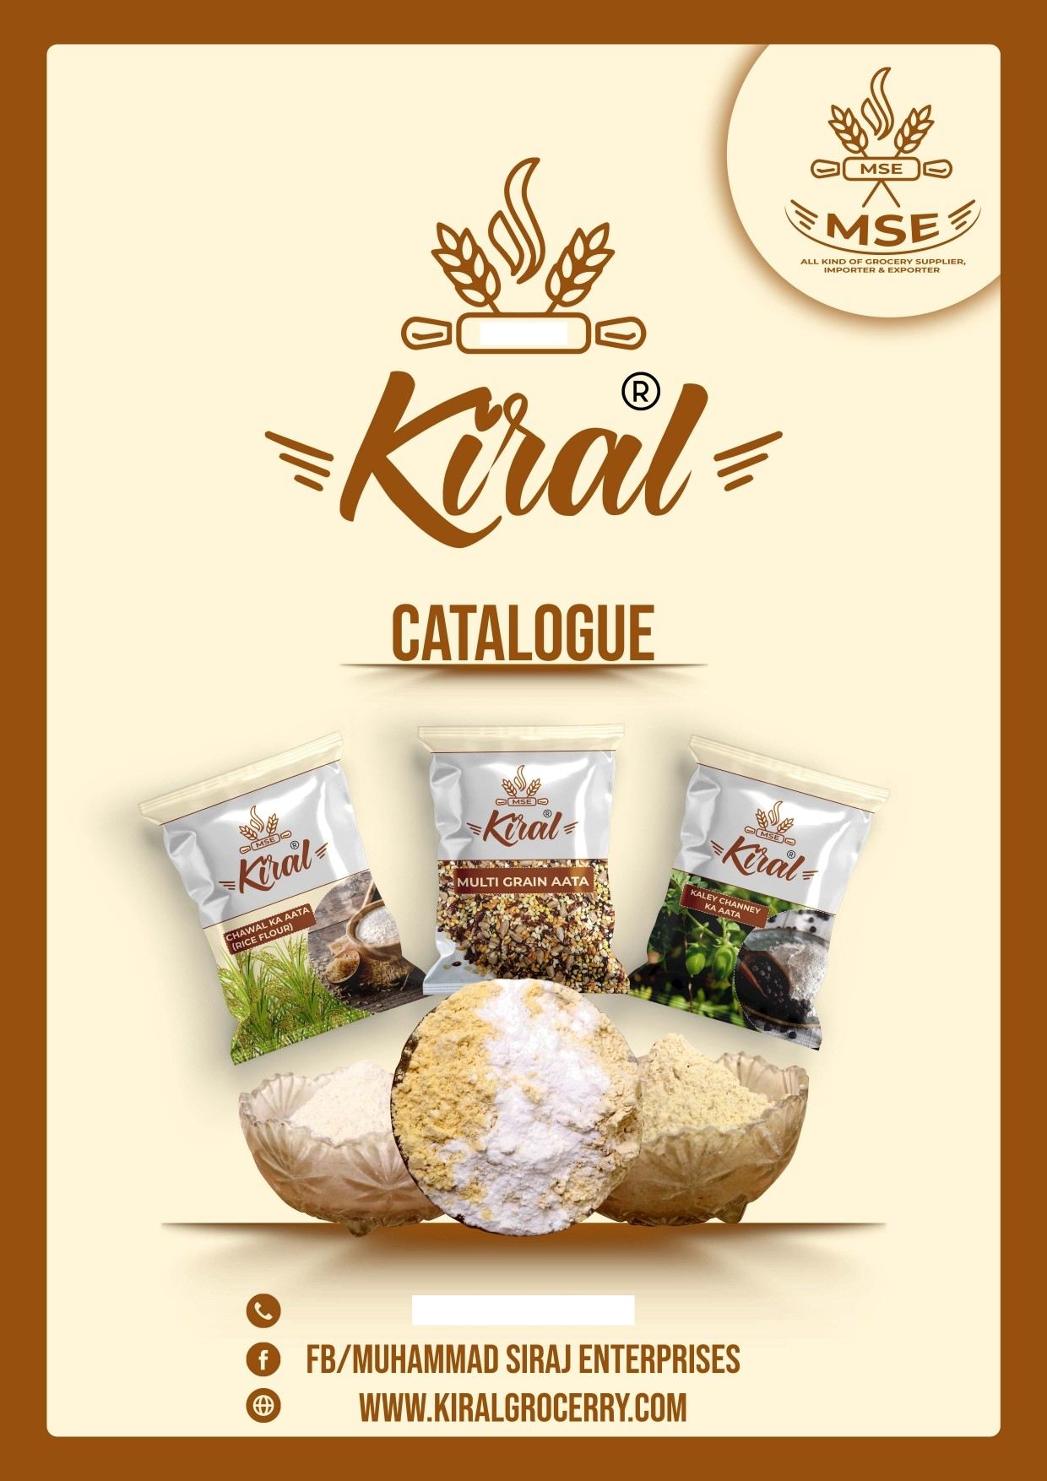

+92333 3525122





MSE



MUHAMMAD SIRA3 ENTERPRISES

0*

## OUR VISION

To be the best hygienic food stuff supply all over the country.

OUR MISSION

Supply the best and hygienic products to our end users with

minimum profit.

WHO WE ARE

Muhammad Siraj Enterprises was built in Pakistan for more than

30 years. Our supply is all over the country. The company started with a mission to serve a hygienic product to our clients, We are committed to providing wholesome products that fit your lifestyle. That is why we continue to add to our growing list of natural, organic, and gluten-free lines. It is part of living up to our promise to provide you with fresh.

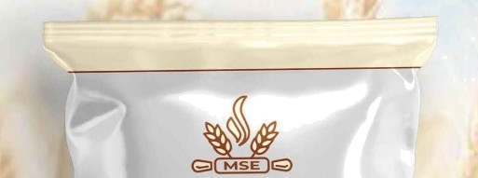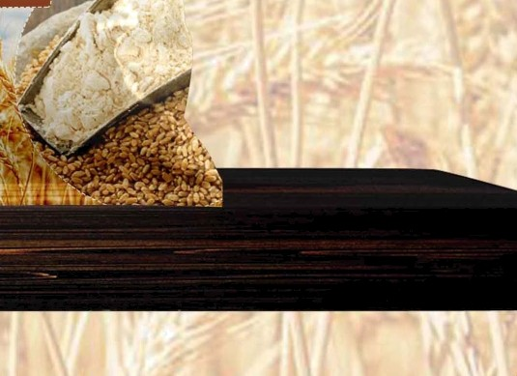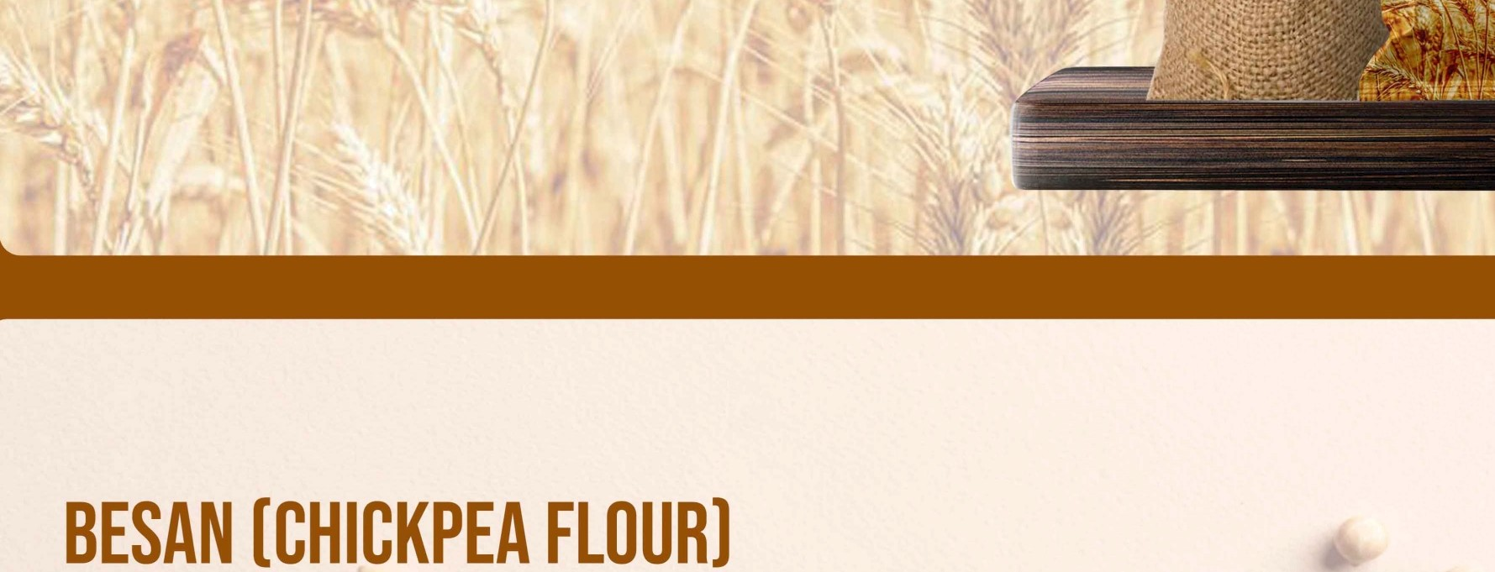

'„„

tNA$hl hA $llTA

WITH ATTENIION ARE WIT UT COMPR;OMISI hfG ON THE QUALITY, ’i

WE Gg|ND Tf0E FINEST FLOUR SO THAT YOUR .CFI@PATI IS S SI'•'IOOYN EVEN TIME. t.‘

BE IT FOR MAKIN

KORAY OR DAHI BARAY IN RAIN OR TO 3UST EN3OY

PLE CURRY, THE QUALI OF BESAN IS EVERYTHING.

PAKORAY IVIADE FROM OUR **BESAN** LEAVES Y WANTING  MORE FOR TASTY SNACK.



1 *



FEWER **CALORIES** EQUALLY FILLING 



**ADHD FOR WS**

8AJRET KA AATA (MILLET FLOUR)

ALONG WITH BEING USED IN MAKING ROTI, BA3RAY KA AATA IS DOI IINANTLY USED IN IVIAKING SWEETS TOO, BECAUSE OF

THE NATURAL NUTTV FLAVOUR OF THE GRAIN. WE HANDLE BA4 RA WITH MUCH ATTENTION AND DETAIL SO THAT



THE NATURAL FLAVOUR OF THE GRAIN IS NOT LOST.

* KEEPS CHOLESTEROL LEVEL IN CHECK
* GOOD PROTEIN SUPPLEMENT m NO GLUTEN FLOUR

m GOOD FRIEND OF DIABETES PATIENTS

## tWAWALKAAATAlQltEFL0UQl

OUR FINE RICE FLOUR HAS THE RIGHT CONSISTENCY AND TEXTURE TO GIVE THE MOST WHOLESOME ROTI’S AND



THE MOST MEMORABLE FEEL.

* + HIGH CALCIUM CONTENT
* 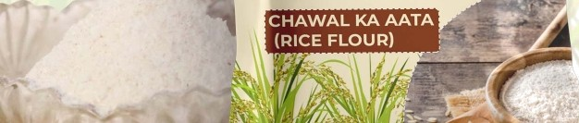COMPLETELY GLUTEN FREE
* KEEPS BLOOD SUGAR LEVEL IN CHECK m GOOD FOR SKIN

# DIETAATA

WITH A BALANCED AMOUNT OF NUTRIENTS AND HELPFUL IN KEEPING DIABETES AND CHOLESTEROL LEVEL IN CHECK, DIET ATTA IS GOQD FOR HEALTHY DIET.

* EFFECTIVE IN DIET CONTROL
* HELPFUL FOR PATIENTS WITH Cj4RDIOVASCULAR DISEASES m KEEPS CHOLESTE¥tOL CONTROLLED

m GOOD FOR A CONTROLLED DIET



# tWOKEQlWWEATBQANl

IT IS CONSIDERED AS ONE OF THE BEST NATURE'S RICHEST SOURCES OF NATURAL FOOD FIBER. OUR TOP-NOTCH QUALITY WHEAT ALSO GUARANTEES A TOP-NOTCH QUALITY CHOKER. PRODUCED ORGANICALLY AND HANDLED WITH CARE,

OUR PRODUCT IS BOUND TO BRING A POSITIVE CHANGE IN YOUR LIFE.

* MULTI-USE BY-PRODUCT OF WHEAT m SMOOTHENS DIGESTIVE FUNCTIONS
* 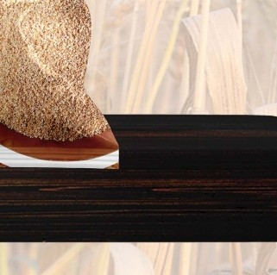PROVIDES HIGHER ENERGY TO BODY ,
* ESPECIALLY GOOD FOR PEOPLE WITH DIABETES

! I i’ I "

....,

* | ’ -- “ - I } , ’ -- “ -- -- ” ] '“ ’

## |NSTANTKNEEQAATA

IVIINIMIZING YOUR EFFORTS WHILE KEEPING THE TEXTURE EXTRA SIVIOOTH AND CREAMY. OUR KHEER AATA EASES YOUR WORK LOAD WITHOUT AFFECTING THE QUALITY OF YOUR FAVOURITE DESSERT. IVIADE WITH ONLY THE BEST RICE GRAIN, OUR KHEER DATA IS SURELY GOING TO HAVE YOU COIyIING BACK FOR MORE.



|  |  |  |
| --- | --- | --- |
| * M NG YOUR KHEER SMOOTH AND CREAMY |  | -• |
| * iINIraIZES YOUR Er»ORT”, *, . .. . *. ,* | ” ,; | " |
| * ENHANCING THE TEXTURE OF YOUR FAVOURITE DIREfiT | ¿. |  |
| m ONLY THE BEST QUALITY RICE GRAINS “ ” ’• " |  |  |

### GANDUM KADALITA

A ,” CELLENT MEAL TO IMPROVE AND SUSTAIN YOUR HEALTH THE LONG RUN. ALL PRODUCED ORGANICALLY,



WB MAKE SURE EACH SPOON OF OUR DALIYA IS FULL OF NATURAL NUTRIENTS AND IS THE BEST FOR YOU.

.m I¥4PROVES AND SUSTAINS GOOD HEALTH

* HELPFUL IN COMMON DIGESTIVE DISORDERS
* PACKED WITH WHOLESOME GOODNESS 
* FULL OF FLAVOUR AND NUTRIENTS ALIKE.

#### JAUKA AATA (BARLEY FLOUR)



3AU FLOUR MADE BY US IS ONLY MADE WITH THE SUPREME QUALITY

3AU GRAINS. THESE sUpREME QUALITY GRAINS PRODUCE NOTHING BUT TFiG-BESE3AU FLOLIO, FINEST IN TEXTURE AN& BEST-11‘4 TASTE-—

* REDUCES CHOLESTROL AND"BLOOD SUGAR
* YOU,R BEST FRIEND IN WEIGHT LOSS
* GOD FOR A HEALTHY HEART





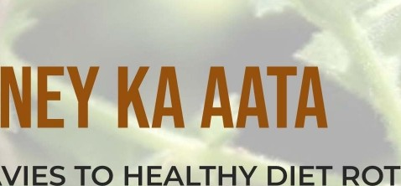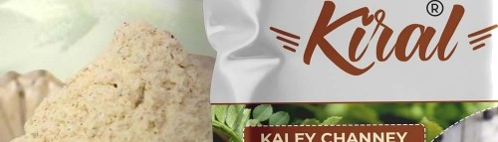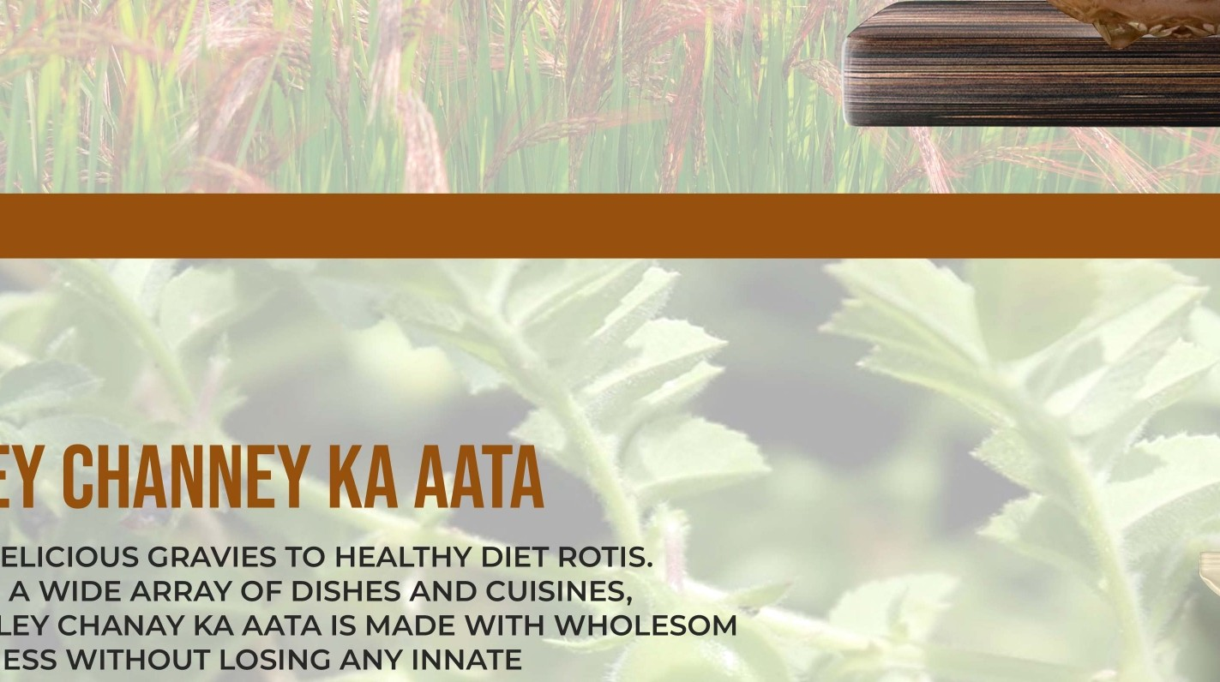

/Y BETLS F

"•,fv@BE I N

AN ADVANTAGES OF

G LAL CHAWAL

ION TO DIET. OUR GOVT.URAL AND ORGAI'TIC

PRQDUCE OF LAL CHAWAL FLOUR GUARA’NTEE COMPLETE BENEFITS pC{F THE GRAIN.

0 G,ANI\ C RJNDING MAKES SUNG

BLOOD P,@ESSUBE•y.

,›

q

FLAVOR OF THE

IC EAS ITSELF.

•A FLAIRS--UL AND NU3gtITIOUS DIET FOOD

* POS IN WEIGHT LOSS

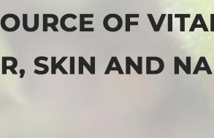m HOLESOME S VITAMIN AN INERAL ESSENTIALS.

m ENHANCES HAIR, SKI N IL H

#### JAUKADALIYA ’”

UNDERSTANDING THE HEALTH BENEFITS OUT UT ,

WE TAKE SPECIAL PRECAUTION IN PRODUCI JOE BEST,“-

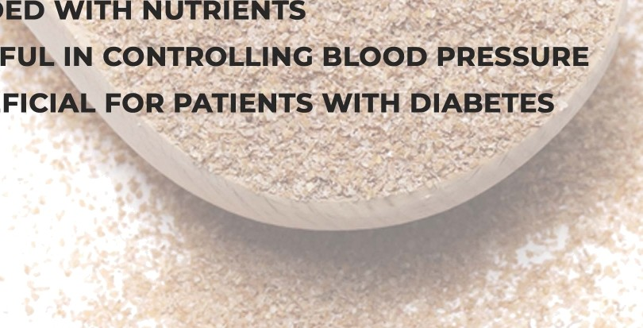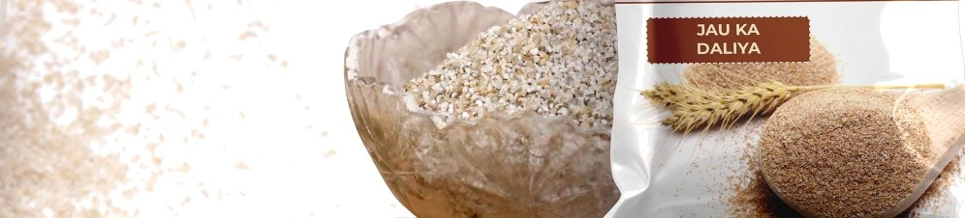

ORGANIC AND HEALTHY DAL|YA,FOR EVERYON WE DON’T COMPROMtfSE0 1Q£JAtLITY OF OUR

* LOAD D
* HELP IN
* BENEFIC

MULTIGRAINAATA “



FROM DESI KULCHAY AND PURI TO PARDESI COOKIES, MULTI GRAIN AATA CAN SERVE AS A BALANCED

ADDITION TO YOUR DIET AND ALSO ADD DEPTH OF FLAVOUR TO YOUR BAKED ITEMS.

* PROVIDES A DEPTH OF FLAVOUR • • • • •
* BEST OF ALL GRAINS IN ONE
* ENHANCES TEXTURE OF YOUR DISHES

o HIGHER NUTRITIONAL CONTENT THAN OTHERS

##### ” - - “

MAS§ KAAATA



A STAPLE FOR A VARIETY OF DISHES FROM DIFFERENT CUISINES, GOOD IVIASN KA TA CAN TURN TDUR DISHES TO MASTER PIECE “ AND VICE-VERSA. WE WORK WITH EXTRA ATTENTION S6 THAT

.FLOUR DISHES ARE ALWAYS A MASTER PIECE.

* GOOD SOURCE OF FI EQr A “
* KEEPSYOU FULL SHOUT WEIGHT. GAIN T ■ PROVIDES ANTIOX1DANTS
* HELPS PEOPLE WITH HEART PROBLEMS

# MAKAlKAAATA

YOU CAN DITCH THE OTHER BRANDED MAKAI FLOUR BECAUSE

WE HAVE FOR YOU THE HEALTHIER AND MORE ORGANIC SUBSTITUTE TO IT. OUR IVIAKAI FLOUR IS MADE ORGANICALLY WHICH KEEPS MORE NUTRIENTS ENTRAPPED IN IT, UNLIKE OTHER ONES,



AND CAN BE USED FOR ANY PURPOSE LIKE THE BRANDED MAKAI FLOUR

* ORGANICALLY GROUND

m MORE PACKED NUTRIENTS

* ABUNDANT AMOUNT OF ANTI-OXIDANTS
* PREVENTS CANCER AND ANEMIA

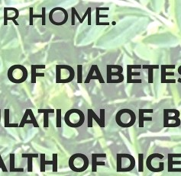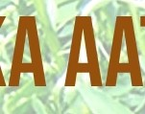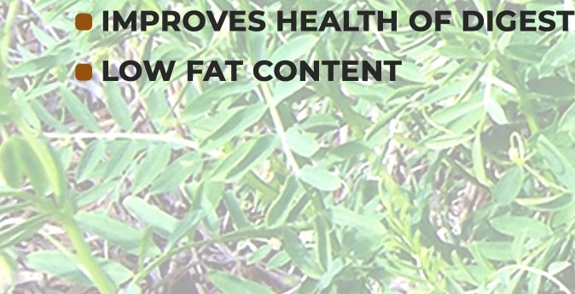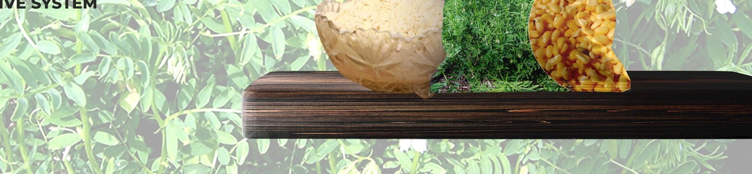

UfSIŃÉS “

L'AATA“,

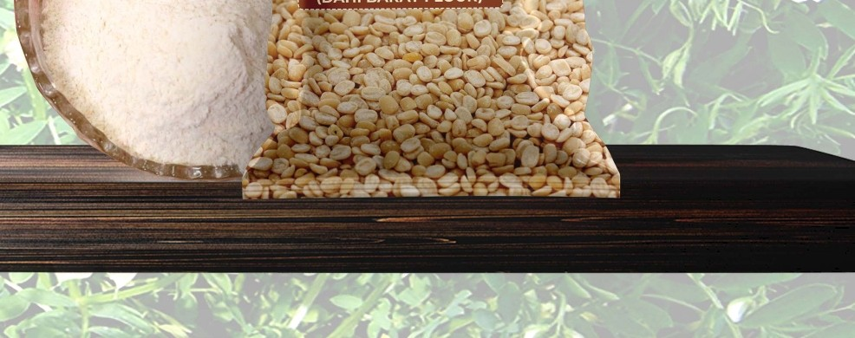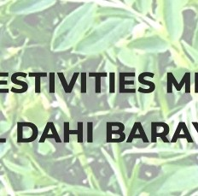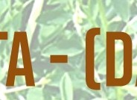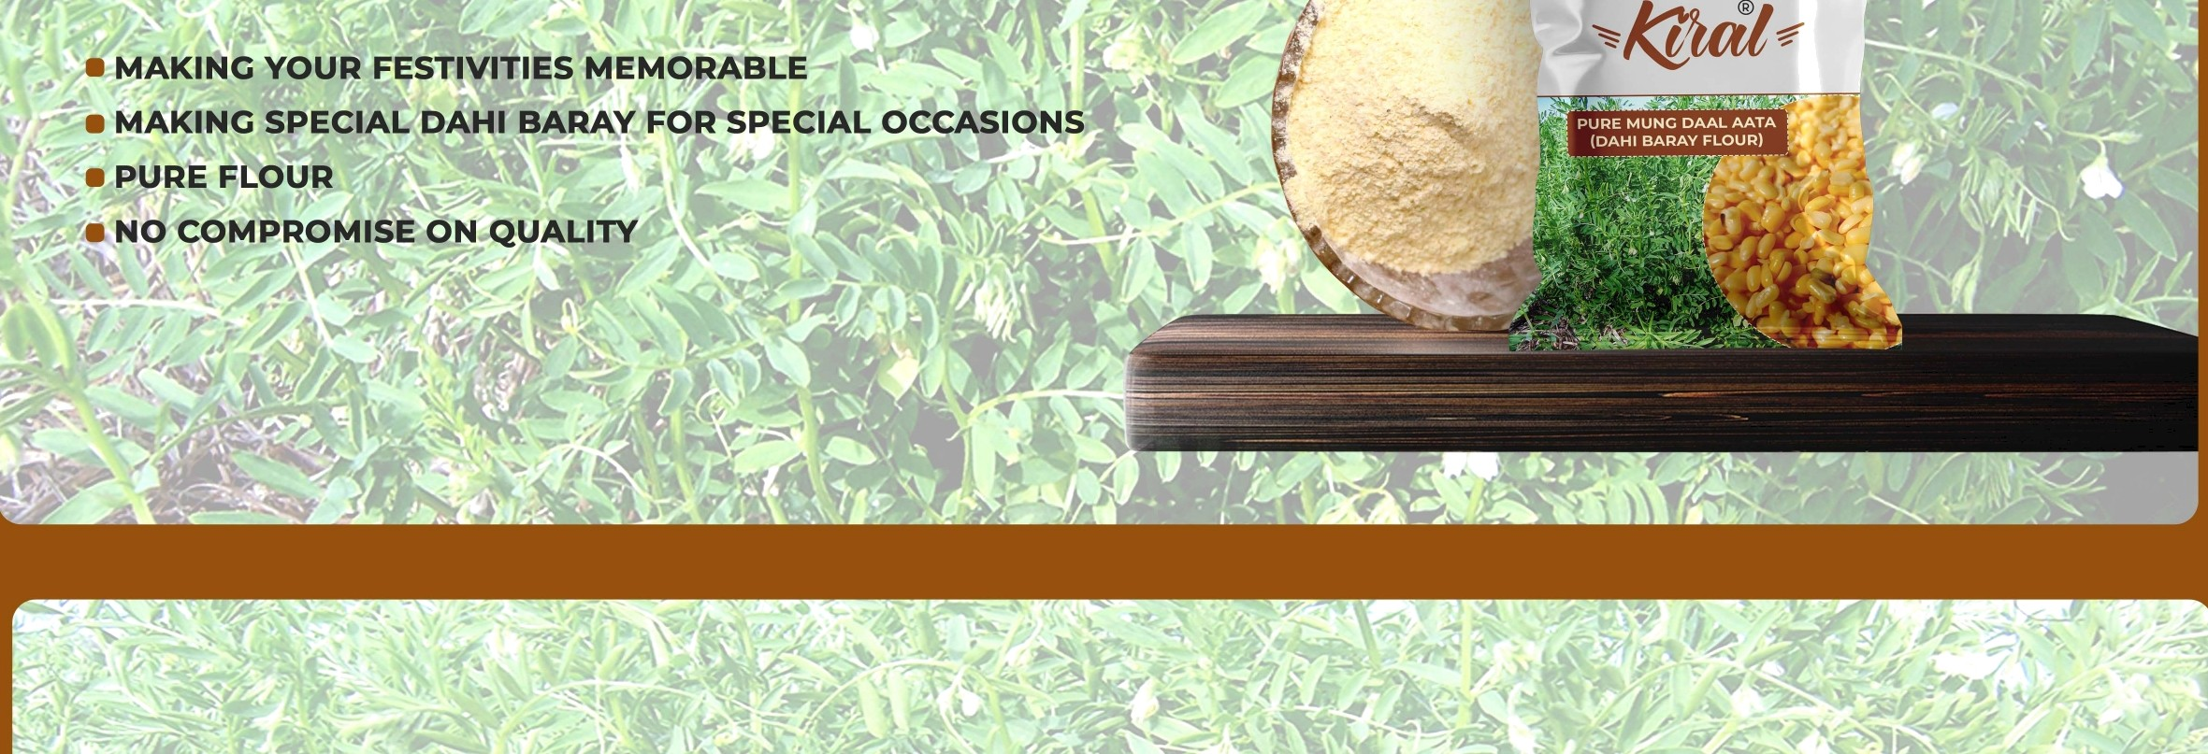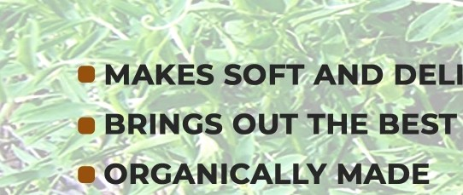

ANO, DELICIO ,

DĄM

1

AI4TIN